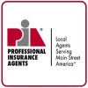 AWIA 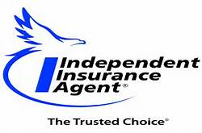

CONVENTION JUNE 12-14, 2018 RED LION HOTEL, CHEYENNE, WY
(FORMALLY Radisson Hotel)
Sponsorship Opportunities
Wednesday Night Cocktails sponsors $3000 Platinum
Thurs Annual Dinner sponsors $3000 Platinum
Thurs Night Entertainment (dueling pianos) sponsors $3000 Platinum
Thurs Breakfast sponsors $2000 Gold
Thurs Lunch sponsors $2000 Gold
Thurs Cocktails sponsors $1500 Silver
Weds Night Food sponsors $1500 Silver
Young Agents Event sponsors $1500 Silver
Weds Fishing sponsors $1000 Bronze
Coffee Break Sponsors $1000 Bronze
All sponsorships include Exhibit booth $450 value and one Convention pass

Yes, sign me up for the______________________________________ Sponsorship

Company Name: ______________________________________________________________

Name on Badge-title/designations_________________________________________________

Address______________________________City/State/Zip_____________________________

Phone___________________ E-mail__________________________________________

Method of Payment (circle one) Check enclosed Credit card, info below

Name of Card: _________________________ Card Number___________________

Expiration Date____________ Security Code ________________
Complete and return form to awia@vcn.com or mail to
Association of Wyoming Insurance Agents
197 Pine Haven Rd
Pine Haven, WY 82721
AWIA Federal ID#83 0313900 Phone 307 201.4801

