AWIA 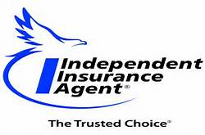

63rd CONVENTION JUNE 12-14, 2018
RED LION HOTEL, CHEYENNE, WY
(formally RADISSON HOTEL)
Full Registration Member Agency ------------- $225.00
2nd Registration same Agency or Spouse ------ $150.00
Company Representative ------------------------- $225.00

Agency/Company Name: _____________________________________________________

Name on Badge-title/designations_________________________________________________

Address______________________________City/State/Zip_____________________________

Phone___________________ E-mail__________________________________________

Method of Payment (circle one) Check enclosed Credit card, ($10 convenience fee) info below

Name of Card: _________________________ Card Number___________________

Expiration Date____________ Security Code ________________

Refund Policy: Cancellations received by 5/31/2018 will be given full refund, NO refunds after that date.

AWIA Convention Room Rates at Red Lion Hotel Cheyenne $109 – Call 307.638.4466

Complete and return form to awia@vcn.com or mail to
Association of Wyoming Insurance Agents
197 Pine Haven Rd
Pine Haven, WY 82721
Phone 307 201.4801
AWIA Federal ID#83 0313900

